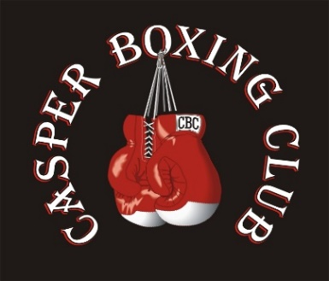
Waiver and Release of Liability
Casper Boxing Club (hereinafter, “CBC”):
- I understand the nature of Casper Boxing Club’s activities. I further acknowledge that I am aware that the activity may be conducted in facilities open to the public or members of the public and/or employees of another corporate entity or entities, during the activity. I further agree and warrant that any time, if I believe any condition to be unsafe, I reserve the right, without penalty, financial or otherwise, to immediately discontinue further participation in the activity and bring such condition to the attention of the management of CBC.
- I understand that (a) the activities of CBC involve risks and dangers of serious bodily injury, including permanent disability, paralysis and death (“Risks”); (b) these Risks and dangers may be caused by me or by the actions or inactions of others participating in the activity, the conditions under which the activity takes place, or by the actions or inactions, including negligent acts, of the below described “Releasees”; (c) there may be other risks and social and economic losses either known to me or not readily foreseeable at this time, and I FULLY ACCEPT AND ASSUME ALL SUCH RISKS AND ALL RESPONSIBILITY FOR LOSSES, COSTS, AND DAMAGES incurred as a result of my participation in these activities.
- I acknowledge that I have been and am hereby advised to seek and obtain any necessary medical clearances from my physician prior to my participation. I acknowledge that I am physically fit and mentally capable of performing the physical activity I choose to participate in. I certify that I have had no injuries to my hands, whether fractures, broken bones, or otherwise, within the three months preceding the dates of completion of this entry form, and have no injuries to the head, concussion, headaches or fainting spells, and should I experience any of these injuries and/or conditions in the future, I will immediately notify the officials of these events and/or conditions, and immediately cease my participation in said events and activities.
- I HEREBY RELEASE, DISCHARGE, COVENANT NOT TO SUE, AND AGREE TO INDEMNIFY AND SAVE AND HOLD HARMLESS CBC, its clubs and their respective administrators, directors, agents, officers, volunteers, and employees, other participants, any sponsors, advertisers, and if applicable, owners and lessors of premises on which the activities take place collectively referred to as “Releasees” from all liability, claims demands, losses or damages whether caused or alleged to be caused in whole or in part by the negligence of the Releasees or otherwise, including negligent rescue operations and further agree that if, despite this release, I or anyone on my behalf makes a claim against any of the Releasees, I will be responsible for the payment to any or all of the Releasees harmed by such assertion of a waived claim, or any expenses arising from my assertion of waived claims or causes of action, including but not limited to reasonable attorney fees and court costs.
- I agree that this agreement may not be modified orally, and a waiver of any provision shall not be construed as a modification of any other provision herein or as consent to any subsequent waiver or modification. Every term and provision of this agreement is intended to be severable, if any one or more term or provision is found to be unenforceable or invalid, said provision shall not affect the other terms and provisions, which shall remain binding and enforceable.
- I agree that photographs, pictures, slides, movies, video, or other media coverage of my participation may be taken in connection with the activities without compensation from Casper Boxing Club and the officers, employees, sponsors, lessees, or lessors, and agents of each of them and consent to use the photographs, pictures, slides, movies, videos, or other media coverage for any legal purpose.
- Non-Compete Agreement: In consideration of the training, coaching, mentoring and competition opportunities provided to the member, the member agrees not to take part or engage in any other boxing competitions, contests or exhibitions outside of USA Boxing while a member in good standing of the CBC and/or for a period of 3 years from the members agreed upon separation date from CBC.

____________________________________________ Date _____/_____/_____
Printed Name of Applicant

Guest Type: Please Check Your Type
____________________________________________ _____Athlete _____Coach _____Staff
Signature of Applicant or Parent/Guardian _____Official _____Parent _____Other*
*__________________________________

